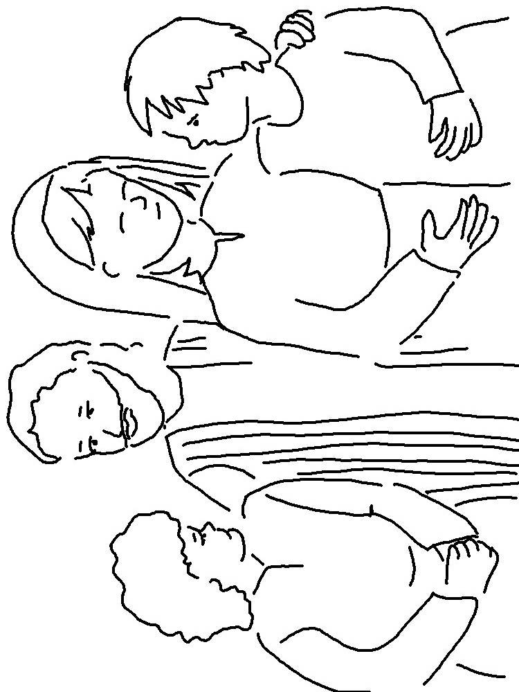
Do not steal. Do not lie. Leviticus 19:11_{NIV}

